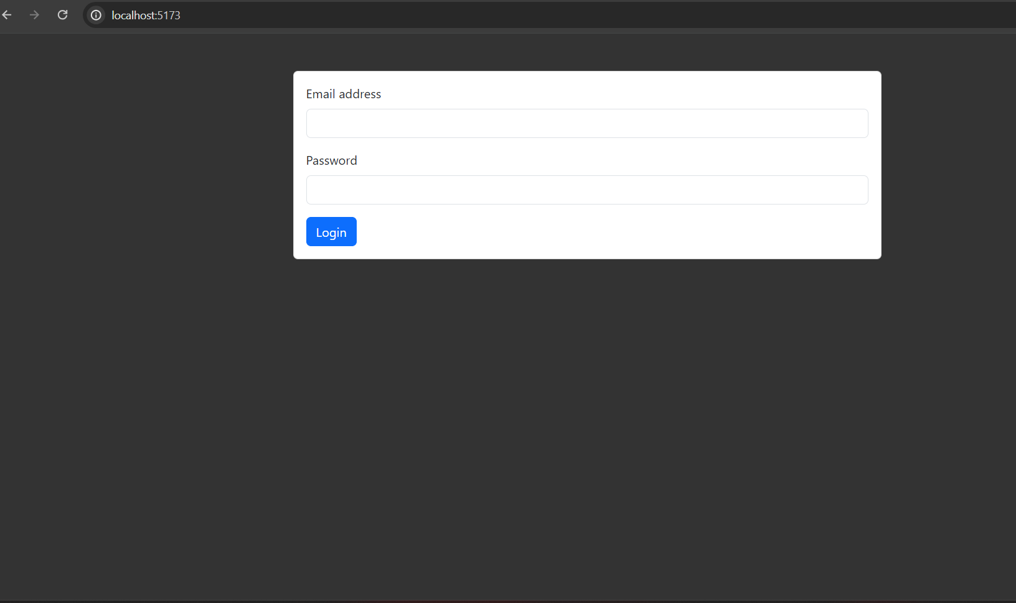  
Login screen

**HR Manager**

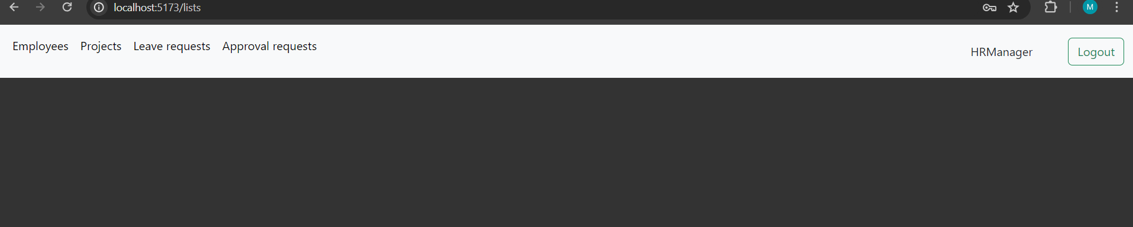  
Hr manager ability to navigate to: employees, projects, leave requests, approval requests

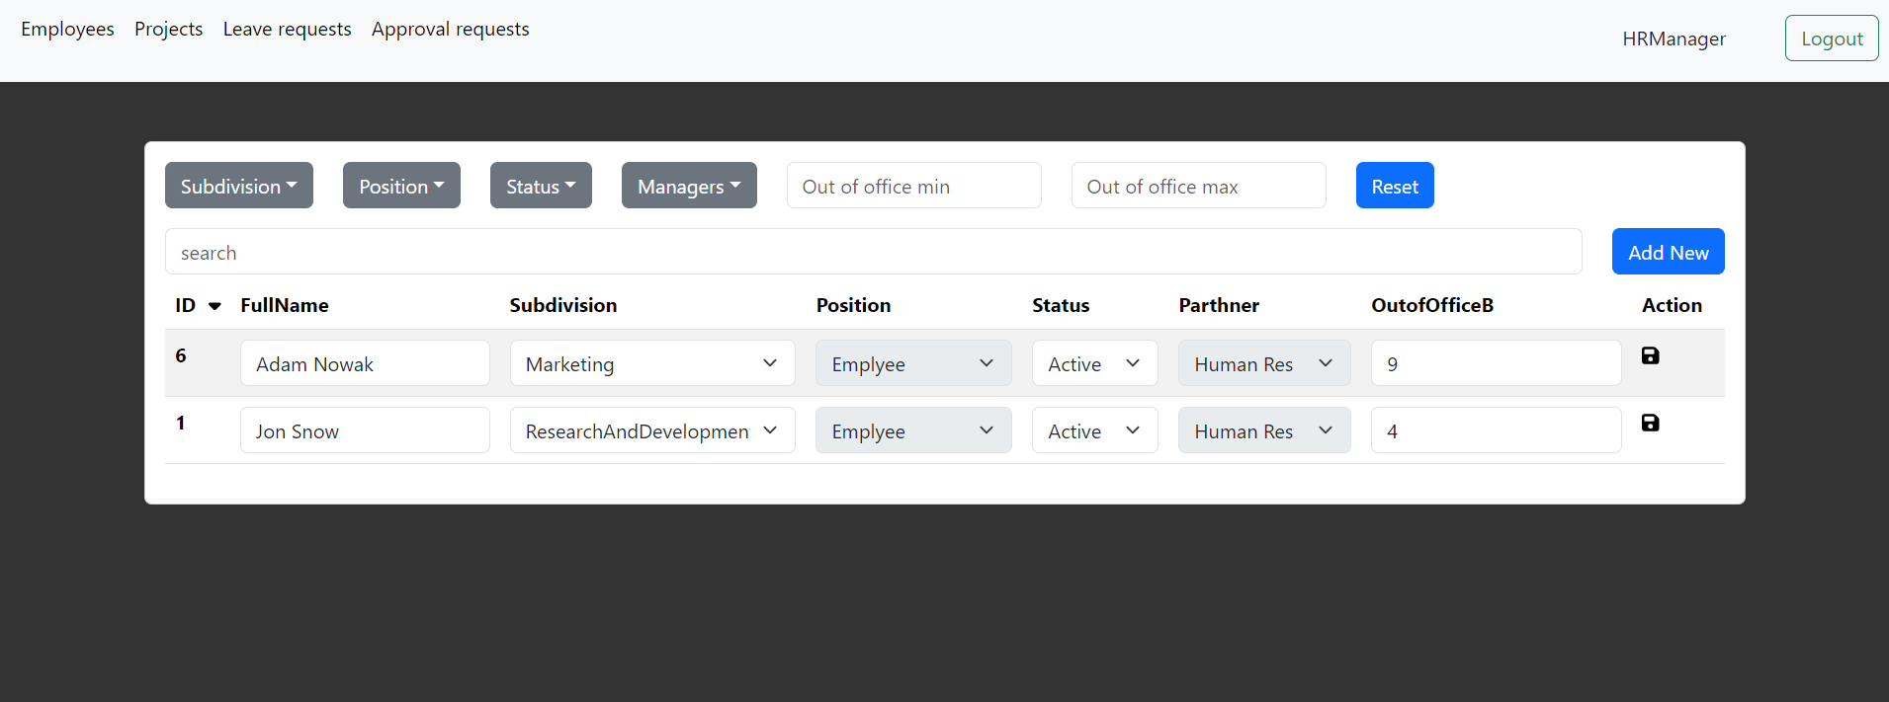  
In the employee list Hr manager see only his employees (employee that have peoplePartner field set to this hr manager id)  
Hr manager can sort employee table by clicking in table header, the small triangle indicates the type of sorting: descending or ascending   
  
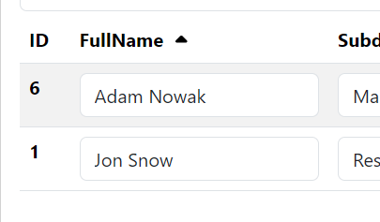



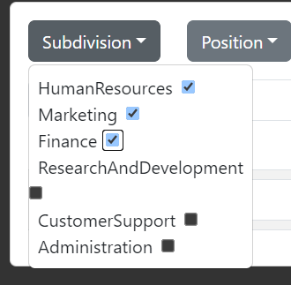 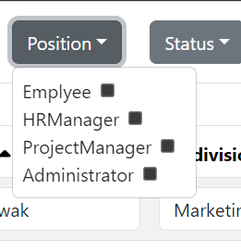 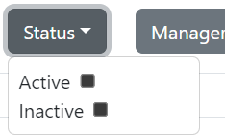

Hr Manager can filter employees   
  
  
  
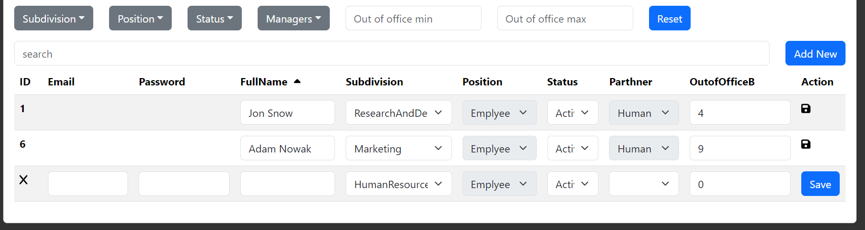  
  


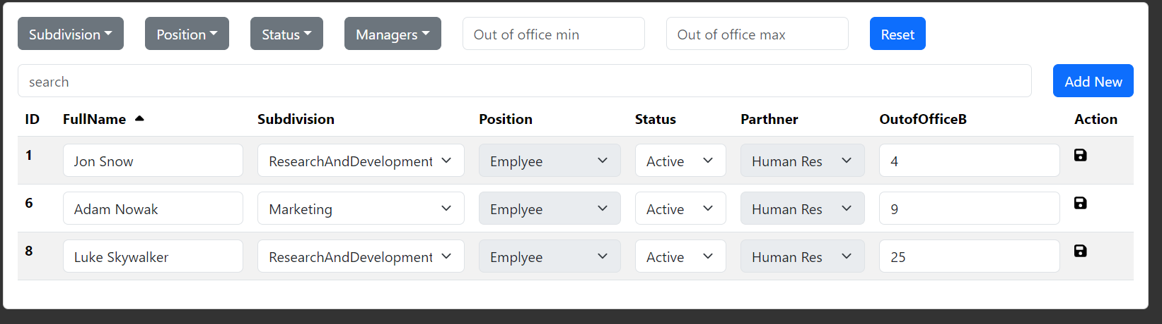  
HR manager can add/update/deactivate employees in the list.

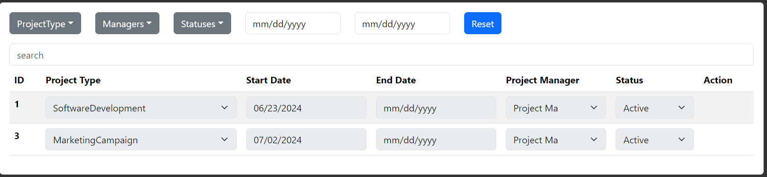  
HR manager sees a list of projects in which his employees are assigned. Can sort and filter project list.

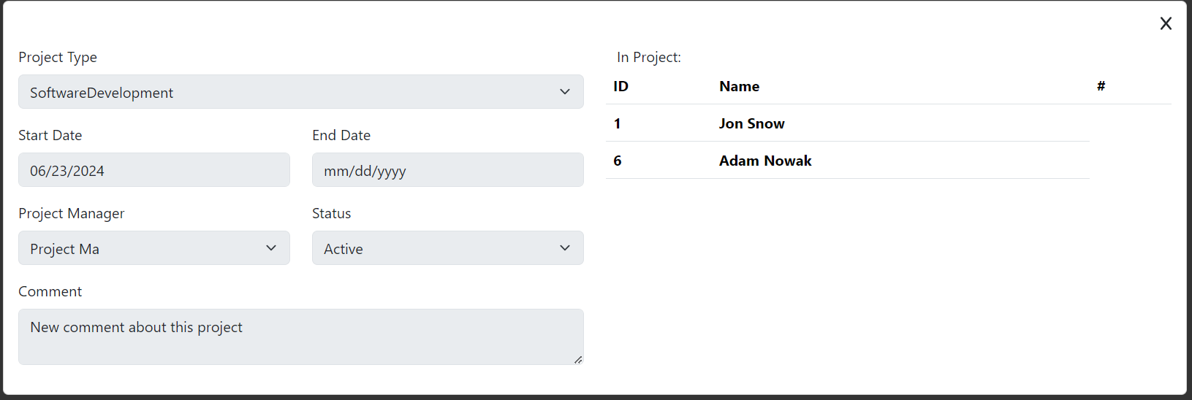  
HR manager can see project details.

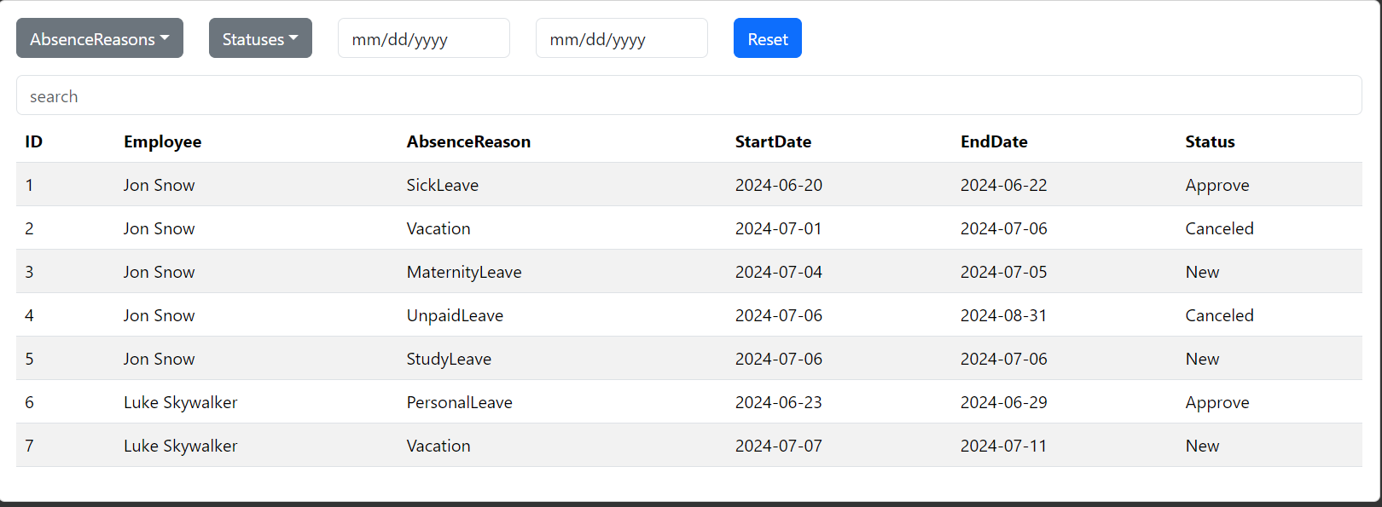  
The HR manager sees the leave request of his employees.

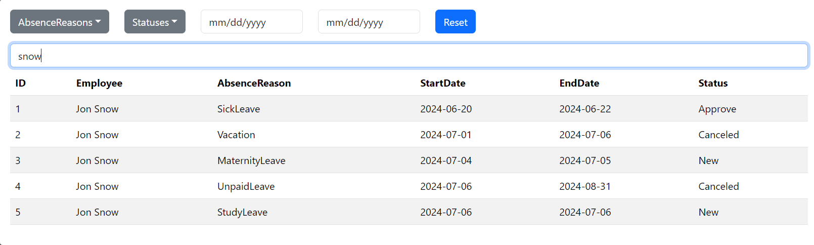  
Can sort filters and search.

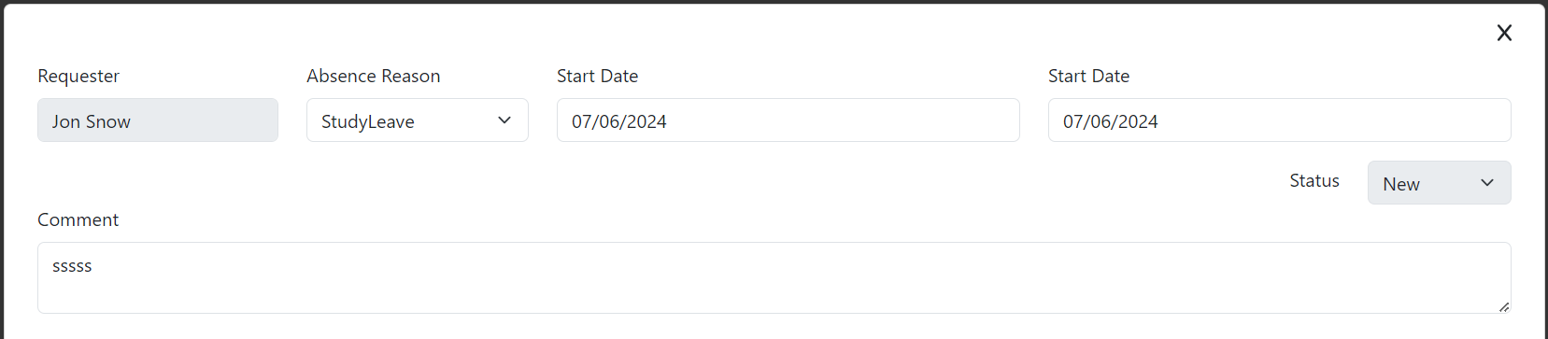  
Open form with details (by double clicking)

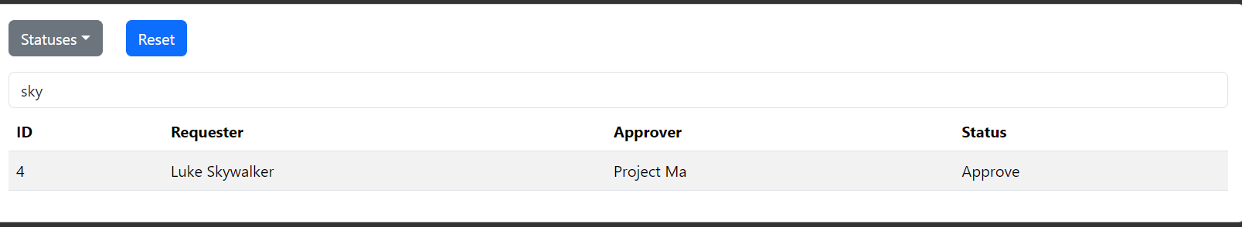

HR manager can sort and filter the approval request table. search

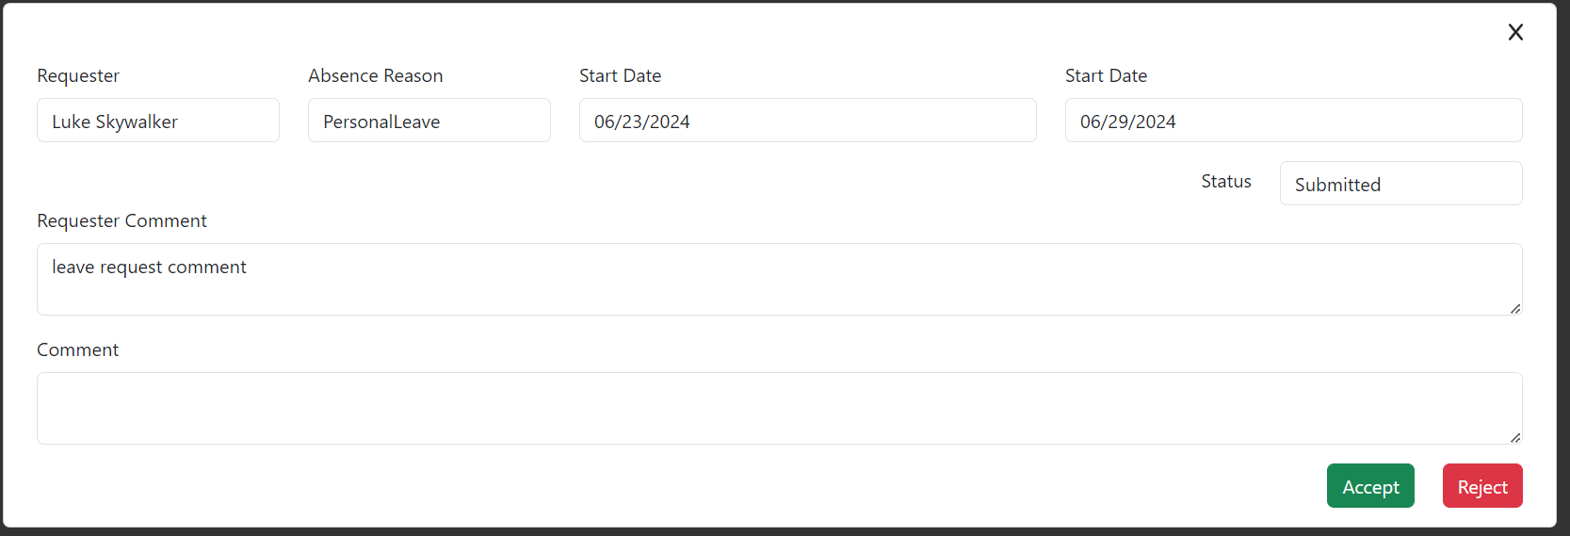Project manager can open the approval request. Can accept or reject it

**Project Manager**

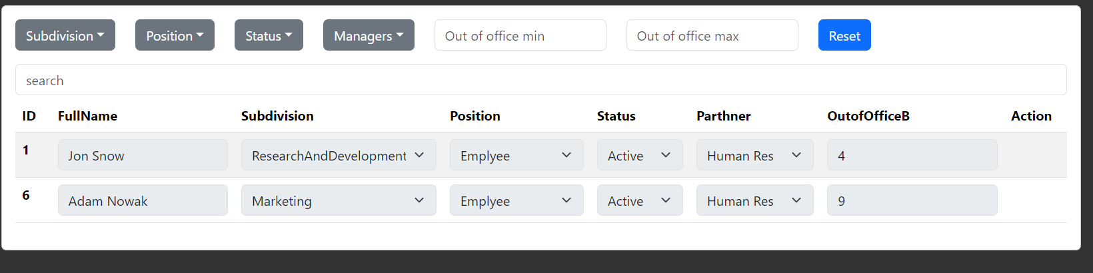Project manager have a read only access to employees related to their projects

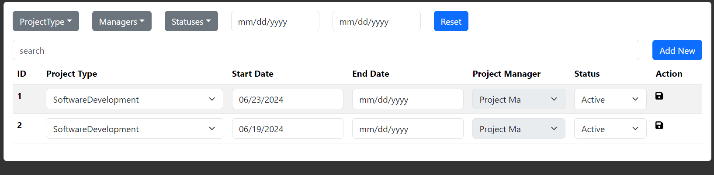Project manager sees his projects. Can sort projects table by clicking in table headers, can filters projects

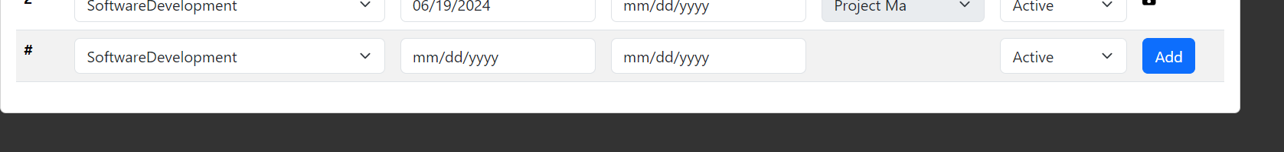Project manager can add/update/deactivate project in the list

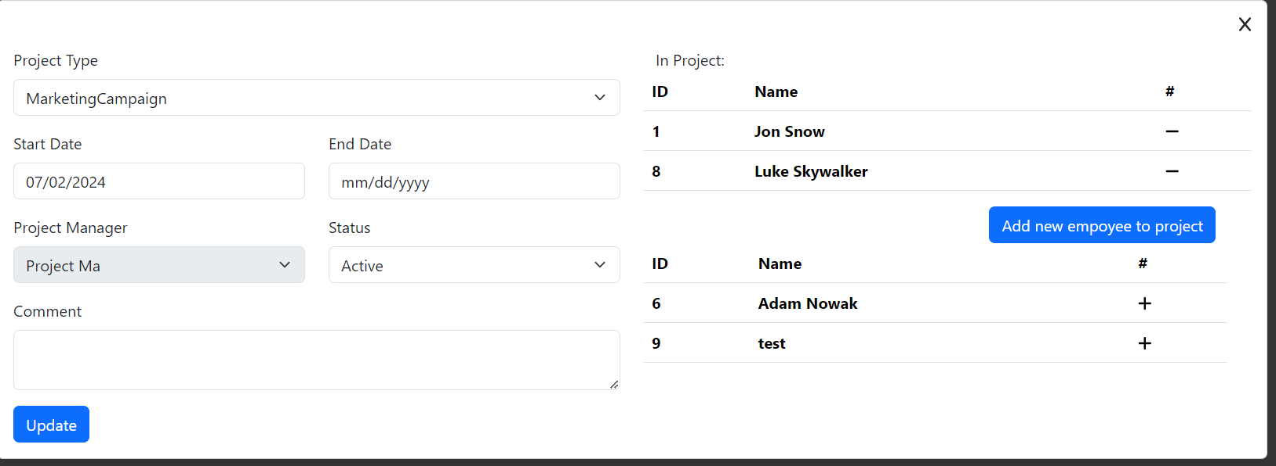Double clicking on the project will open the form with details.

Can update project.

Can assign and remove employees to/from a project.

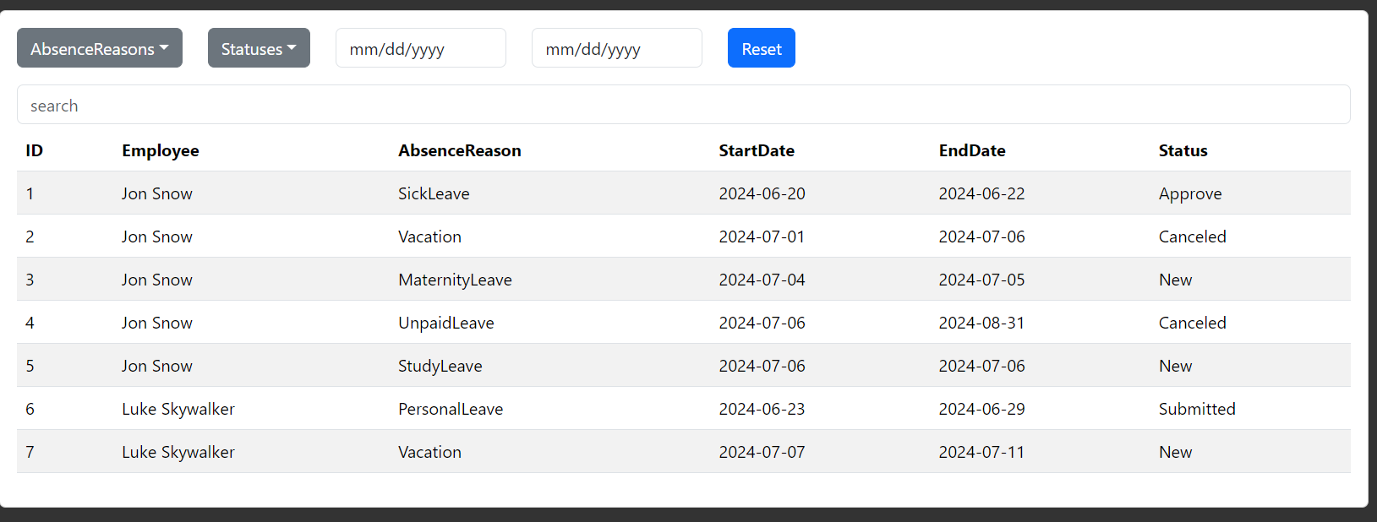Project manager sees employee leave requests from his projects. Can sort and filter tables.

**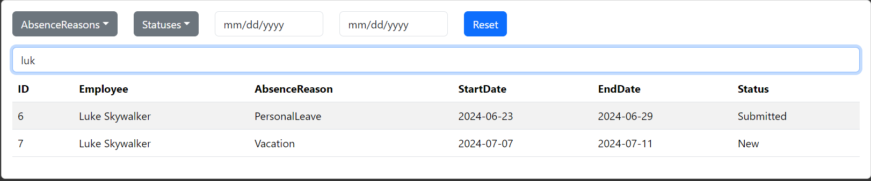  
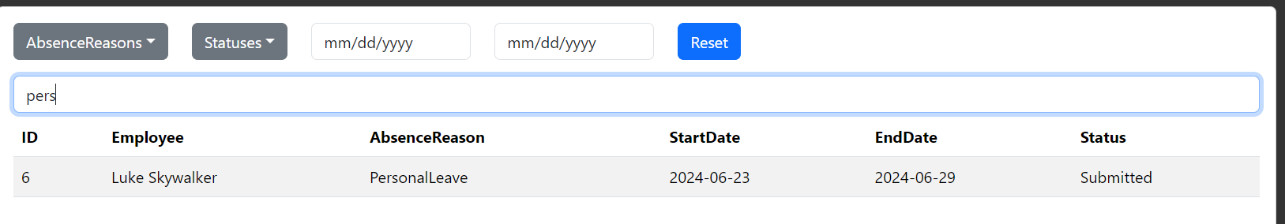**Project manager can search

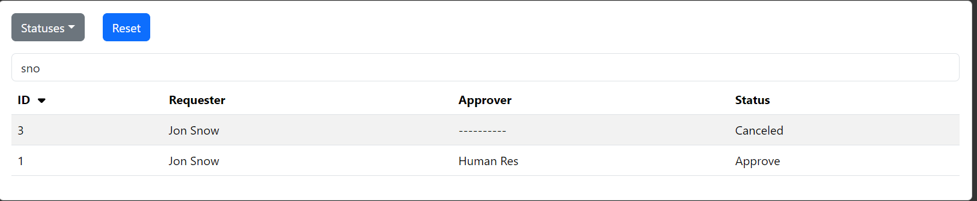

Project manager can sort and filter the approval request table. search

****Project manager can open the approval request. Can accept or reject it



****After accepted Out-of-Office Balance was updated

**Employer**

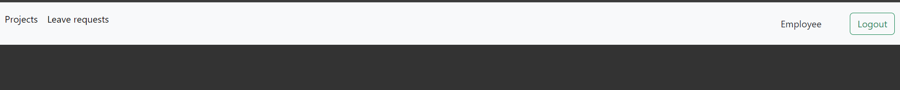

Employer: ability to navigate to: projects, leave requests

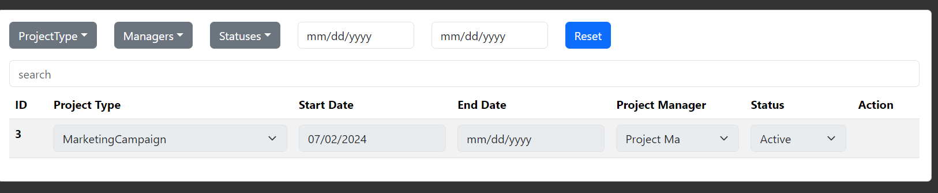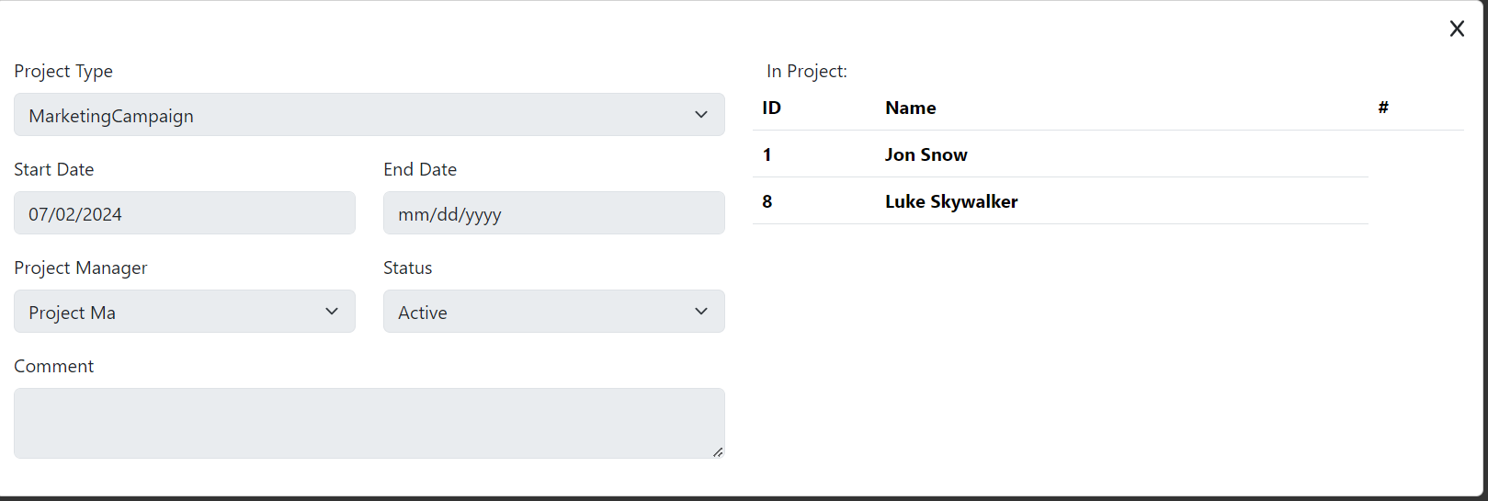  
The employee sees the projects to which he or she has been assigned.

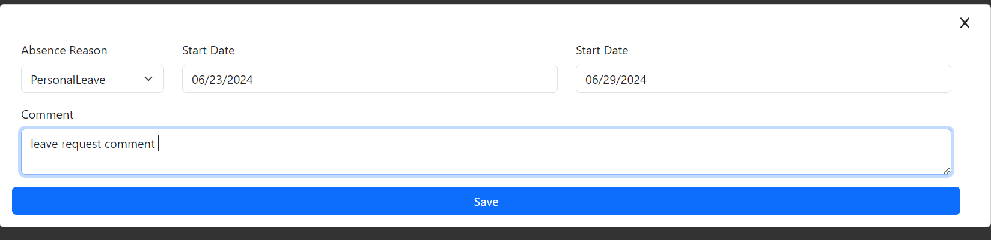

Can create leave request

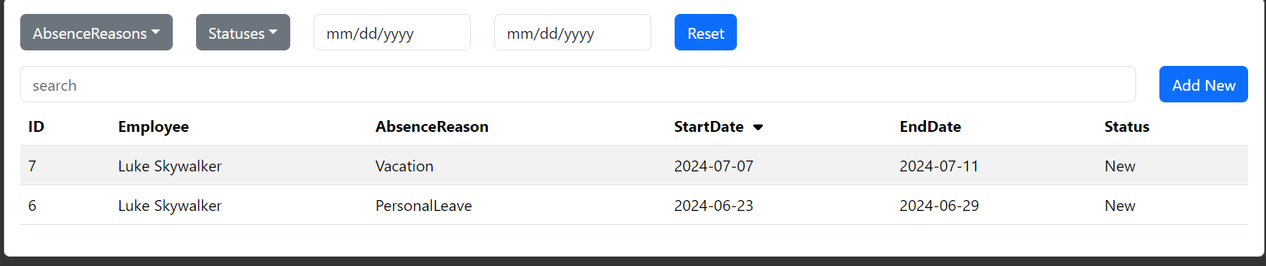  
Can see his own leave request. Can sort table by clicking in table header. Double-clicking on a table row will open the associated leave request.

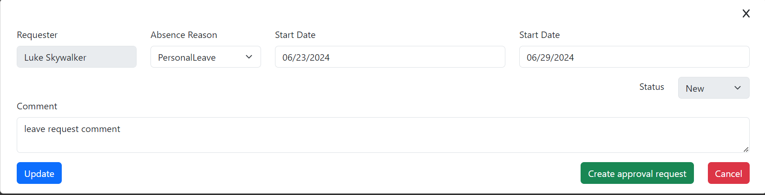  
Employer can update, create approval request or cancel leave request

Clicking “Create approval request” the status will be updated to “Submitted” and a new approval request will be created.

Clicking “Cancel” - status will be updated to “Canceled” and approval request will be canceled if they already exist.

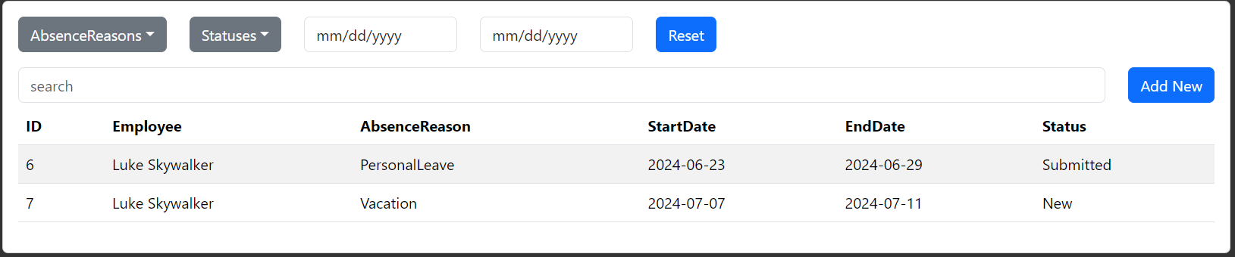

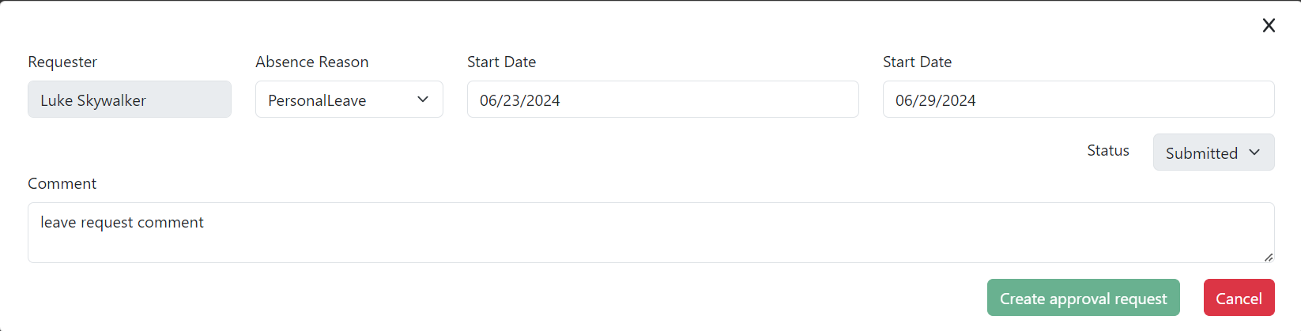  
After submitting a leave request, it cannot be modified, only canceled.

**Administrator**

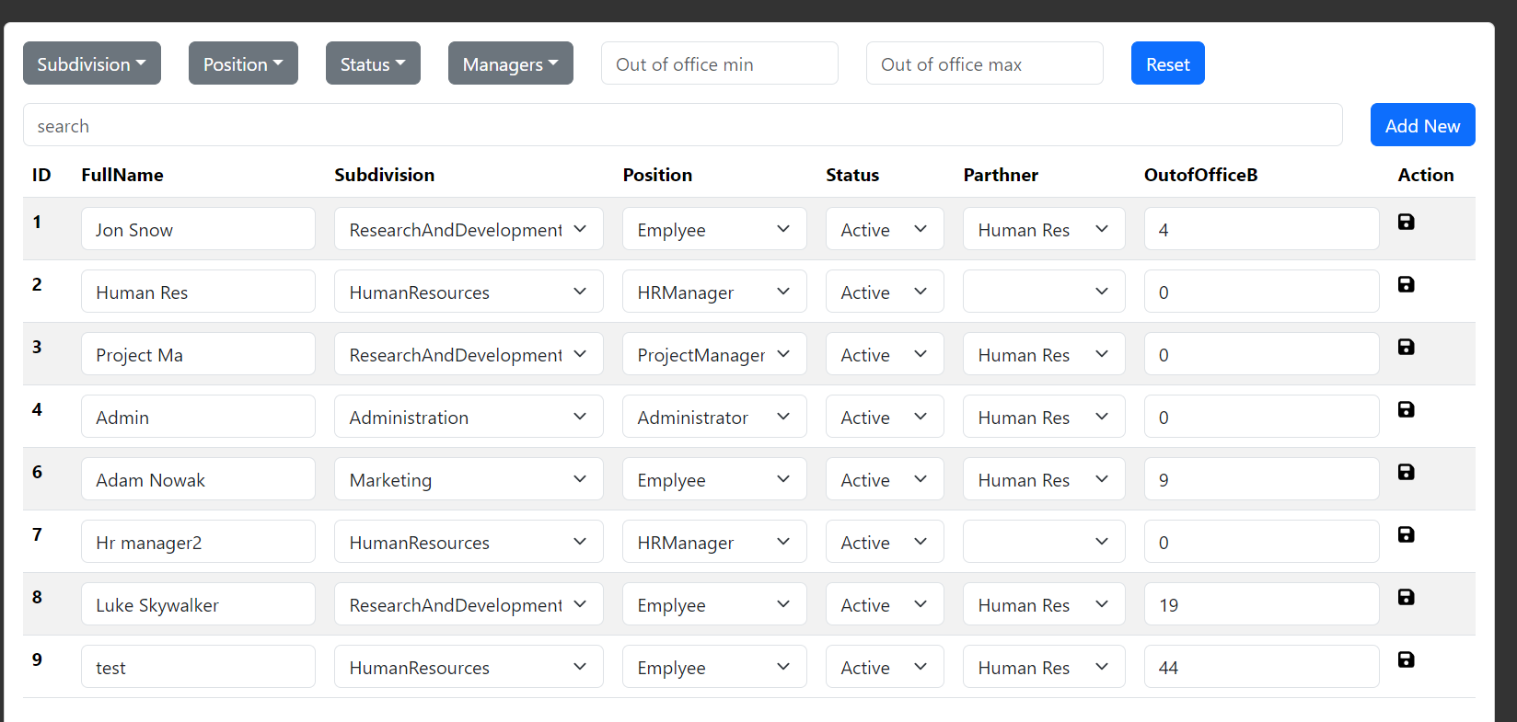  
  
Administrator can create employees of all types, change the type of employee